Link to the old eIRB from the new eIRB system

For studies that migrated from the old system, you will find a link to the new system under the main study history
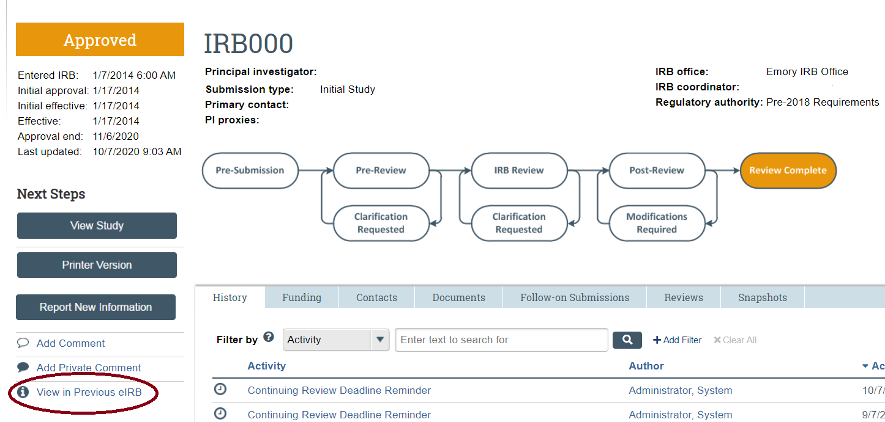

After clicking in the link, a window will open. Click on “Link to legacy record”.
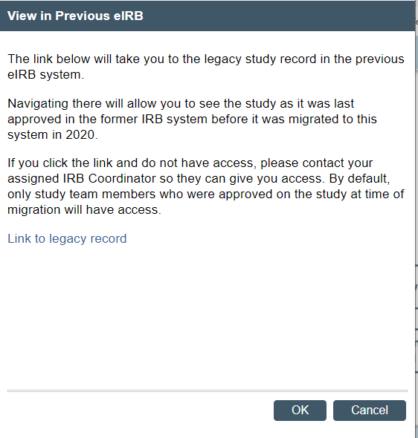
After clicking in the “Link to legacy record”, a new window will open asking you to log in with your Emory credentials. After that, you will have access to the old record.
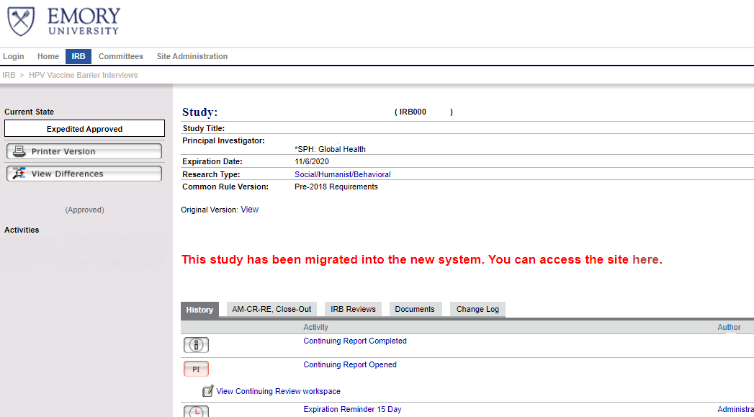
If you were not part of the study team in eIRB when the study was migrated, you will not be able to access the record. Your IRB coordinator can add anyone currently in the study to the old study record.
Note the following:
- The previous link to access the old system is no longer available. Go to https://irbrxemory.huronresearchsuite.com/irbrx for read-only access to your submissions in the old system (if you were part of the study team before the study was migrated) or through the link in the study history in the new eIRB.
- If you were just recently added to the old study record, you will only have access to the study with the link in the study history in the new eIRB.

