IRB 8.2 Site SmartForm
Table of Contents
Basic Information 2
Funding Sources 3
Study Team Members 4
Research Locations 6
Local Site Documents 7
Final Page 9

Basic Information | - Green = Help Text
- * Short title:
- * Local Principal investigator:  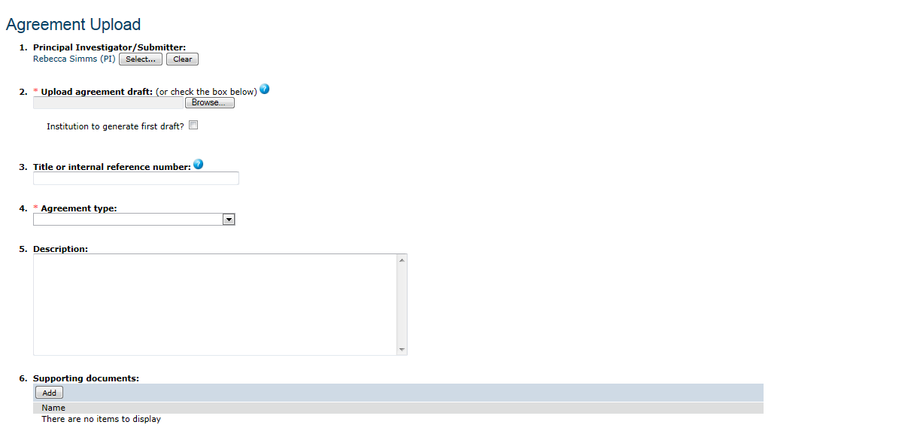 | Local Principal Investigator  Select the principal investigator for this participating site. This is not the principal investigator of the entire multi-site or collaborative study.
- * Does the local investigator have a financial interest related to this research?  - Yes  - No  Clear | Financial Interest Related to This Research  Definition of financial interest:  - Who holds the interest? The individual involved in the research, or the immediate family of the researcher. Immediate family means the spouse, domestic partner, children, or dependents.  - Interest in what? The study sponsor, a competitor of the sponsor, or a product or service being tested.  - What is an interest? Any of the following:  - Ownership interest of any value including (but not limited to) stocks and options, exclusive of interests in publicly-traded, diversified mutual funds.  - Compensation of any amount including (but not limited to) honoraria, consultant fees, royalties, or other income.  - Proprietary interest of any value including (but not limited to) patents, trademarks, copyrights, and licensing agreements.  - Board or executive relationship, regardless of compensation.  - Reimbursed or sponsored travel by an entity other than a federal, state, or local government agency, higher-education institution or affiliated research institute, academic teaching hospital, or medical center.  Important! If an individual has a financial interest, provide a copy of the Conflict of Interest Committee's determination regarding the interest. Attach a copy using the Supporting Documents Page, which appears later in the submission process.
- Brief description of activities this site will perform: (enter “All” if this site will perform all procedures in the protocol) | Brief Description of Activities This Site Will Perform  In a few words, summarize your activities as a participating site in this multi-site or collaborative research study. If your site will be conducting all portions of the research, type “ALL.” If your site will be conducting only certain portions or the research, include a summary.  For example:  This study includes both adults and children as research subjects; however, at this site, we will include only children. Therefore, we will conduct only those procedures related to children.

Additional Local Funding Sources
- Identify each organization supplying funding for the study
Funding Source | Sponsor’s Funding ID | Grants Office ID | Attachments
There are no items to display

- * Funding organization:
- Sponsor’s funding ID: (assigned by external sponsor)
Emory EPEX ID: (required if applicable)
- Attach Files: (include any grant applications)

- *File to attach:
- Name: (if not supplied, the file name will be shown)
- Version number:

Local Site Documents | Local site-specific documents may include local versions of consent forms or recruitment materials.  For multi-site studies:  - Some documents and consent forms will be applied to the multi-site study as a whole. Others may be specific to your institution. On this page, only include the documents that are specific to your institution.
- Consent forms: ( attach local consent/assent documents) | Consent Forms  If consent will not be documented in writing, attach a script of information to be provided orally to subjects.  - Make sure the consent documents, the protocol document, and the contract all use consistent language.
  Documents | Category | Date Modified |  |  | Document History
  There are no items to display
- File to attach:
- Name: (if not supplied, the file name will be shown)
- Version number:
- Recruitment materials: (add all material to be seen or heard by subjects, including ads) | - Recruitment Materials  - Important attachments include:  - ◾Advertisements (printed, audio, and video)  - ◾Recruitment materials and scripts  - ◾Evaluation instruments and surveys
  Documents | Category |  | Date Modified |  | Document History
  There are no items to display
- *File to attach:
- Name: (if not supplied, the file name will be shown)
- Version number:
- Other attachments:
Documents | Category | Date Modified |  |  | Document History
There are no items to display
Suggested attachments:
- Completed checklist of meeting Department of Energy requirements, if applicable
- Other site-related documents not attached on previous forms
- Case Report Forms
- Data Use Agreements
- DSMB Charter
- Surveys, Questionnaires, Interview Guides

- *File to attach:
- Name: (if not supplied, the file name will be shown)
- *Category:

- Version number:

Final Page
- Click Finish to exit the form.  - Important! To send the submission for review, click Submit on the next page. | - Final Page  - When you click Finish on the Final Page, you have not yet finished all the steps to send the submission for IRB review. You have the option to continue editing the submission, and you should check it for errors and omissions. Then, before the IRB can review it, the PI must personally submit it for review.  - Related Topics  - "Create and Submit a New Study" in the Researcher's Quick Reference
  You have reached the end of the IRB Submission form. Read the next steps carefully:

