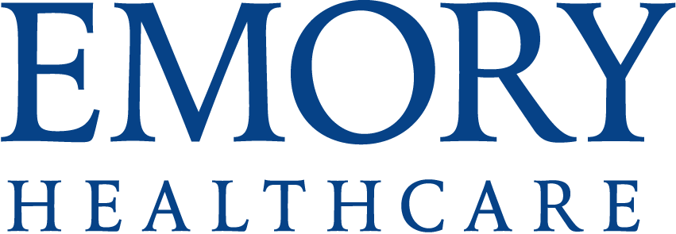

Authorization for Medical Case Study and publication

De-Identified Medical Information

Purpose of Authorization

Patient authorization is not usually required for case studies since they use de-identified patient
health information. some medical journals are now requiring some type of authorization by the
patient. This authorization may be used when the journal requires the author obtain the patient’s
permission for use of the information for the case study. This authorization cannot be used if the
diagnosis is such that it could reasonable be used to identify the patient (for example a rare disease)
This authorization may be obtained by having the patient sign this document, or verbally, depending
on the requirements of the publisher

Patient Name: Mailing address:
City: _____________State:____________ Phone: _________________ DOB___________________________

1. Emory Entities
I consent to and authorize Emory University or its affiliated entities including, but not limited to Emory Healthcare, Winship Cancer Institute, Emory University Hospital, Emory University Hospital Midtown, Emory Orthopaedics & Spine Hospital, Emory Johns Creek Hospital, Emory Saint Joseph's Hospital, , The Emory Clinic, or the Wesley Woods Center, (collectively “Emory”) to use my health information for a medical case study. Only diagnosis and demographic information such as age, sex and race will be used in any published case study. All other medical identifiers will be removed and not use in the case study.

2. Nature AND Purpose of Disclosure
The nature of my health information to be used is diagnosis, care, disease progression, and treatment. I understand the case study will focus on________________________________________. There will be no patient identifiers in the case study and my name will not be used. I understand the case study will be used and/or published for medical education purposes.

3. Re-disclosure
I understand that once the case study is published Emory does not retain control over its editing or use.

4. Refusal to Authorize Use and/or Disclosure
I understand that my refusal to authorize the use of my health information for the medical case study will in no way affect my eligibility to receive medical care at any Emory health care facility.

5. Patient Compensation
I understand that this is voluntary and that I will receive no compensation for the use of my health information for this case study or its publication. I further understand that I will have no economic and/or intellectual property right, title or interest, or any other property right or license in the case study authorized above.

6. Emory Compensation
I understand that Emory will not receive financial compensation from a third party for the case study.

Signature of Patient (or Patient’s Representative) Date

Description of Authority to Act for Patient
Verbal Authorization Obtained ________Yes Date_________________
Name of Emory employee obtaining verbal authorization_____________________________________________________

NOTE: This form must be scanned into the patient’s medical record.
Form specially prepared for case study using de-identified patient information AA 4/4/2015

